2nd Edition 2008
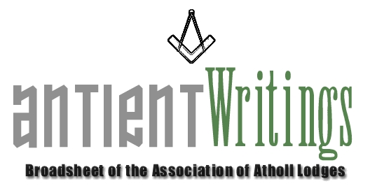

New Blood - URGENT

The Association is now in urgent need of new blood. What about you !!! - Especially if you are interested in joining the Executive Committee, which meets 3 times a year. The Committee is now urgently succession planning for the roles of:

1. Secretary - 2010 onwards 2. Asst Secretary [Membership] - 2009 on
  - Directors of Ceremony [x1] ASAP 4. Events Organiser - For Induction in 2009

It is hoped that many Atholl lodges will respond to this appeal and put forward willing brethren to maintain the work of the Association through active membership of its Executive Committee. This will also be ‘flagged’ on the Web Site.

Annual General Meeting

The 2008 Annual General Meeting was held at Freemasons Hall, Gt Queen Street, on Wed 2nd July which agreed a few minor adjustments to the constitution. The Chairman Geoffrey Abraham gave an upbeat report on the events of the Association and looked forward to the future visit to New York in the Spring of 2009 and the re-planned visit to Jamaica in late 2009 or 2010. He highlighted other substantive issues especially the need for new blood. [Lead Item]

Membership Subscriptions Revised to £10 and £5

The subscription categories have been revised and uplifted for 2009 having been held down for the past three years.
Until a new Assistant Secretary [Membership] can be appointed [anyone interested ?] the 2009 renewals will be dealt with by Paul Gardner, the Secretary. To overcome the hiatus between the systems and protocols set up by Rod [RIP] and to avoid missing any renewals, included within this mailing an application form for every Atholl lodge and contact. Please return the form with your subscription as soon as possible and ideally before the start of 2009. Should you be renewing or hopefully newly joining you will be most welcome as it will help maintain the heritage of the Antients.

Web Site - www.antients.com and webmaster@antients.com

The Webmaster is keen to enhance the ‘Regions’ pages to include ‘info’ and ‘chat’ from any Atholls around the country. Please send any submissions to him [above]. You can also have a ‘click-on’ to your lodge’s web site from the listing page if you wish. Potted versions of ‘your’ lodge history can be easily added to the many pages of history therein.

Midlands Meeting

Athol Lodge No 74 has kindly offered to host the next Executive Committee Meeting. It will be on Wed 1st October 2008 at Birmingham [Severn Street B1 1QG – Parking under the Mailbox Shopping Centre]. The committee meeting will start at 4pm to which ALL are welcome and it will be followed at 6pm by the 74’s Regular meeting at which there will be a significant AAL input. Please try to come ! To attend the lodge meeting and dine please contact: Ron Field Tel: 07973 810274 rongfield@btinternet.com

New York Visit – Proposed Spring 2009

The plan is to fly out Monday. Visit Grand lodge of New York and take in a meeting on Tuesday. Take an Amtrak train to Philadelphia-site seeing-meeting and return on Wednesday. Thursday New York site seeing/shopping. Return on Friday. More information in a later AW edition or contact Lew Hughes on derek.muffin@virgin.net .

New Hope – Rescue a Lodge

The Secretary knows of a group of ‘Atholl’ enthusiasts who are willing to ‘rescue’ an antient lodge rather than let it surrender its Warrant. The plan would be to enrich its membership and move it to Sindlesham, Berkshire where it would have a secure home and future. Any Atholl lodge in dire straits please make contact before it is too late.

Merchandise

There is now a new stock of Ties / Bow Ties / Lapel Pins and available from the Secretary. They are £12.50 and £2.50 respectively. There is now also a ‘longer’ version of the tie for the more portly among us.

You are permitted to wear Association ties at Atholl meetings.

Would Secretaries and Representatives photocopy and distribute as widely as possible

Paul Gardner - 39 Wentworth Drive, Bedford, BEDS, MK41 8QA - 01234 261584 secretary@antients.com

